**The Construction of Dongqu No. 2 Raw Coal Model and Characterization of Forming Methane by Pyrolysis Simulation**

LI Yaogao, WANG Chuange*, ZENG Fangui, FAN Jing

(*Key Laboratory of Coal Science & Technology of Ministry of Education & Shanxi Province, Department of Earth Science &Engineering, Taiyuan University of Technology, Taiyuan, 030024, P. R. China*)

**Abstract:** In this paper, the authors firstly constructed macromolecular structure model of No.2 Dongqu raw coal by extracting the skeleton information of coal macromolecules based on experimental data 13C-NMR, then conducted single macromolecule pyrolysis simulation and five- macromolecule pyrolysis simulation respectively for the macromolecular structure model, and finally analyzed the pyrolysis simulation by combining kinetic parameters after the simulation. It turned out that in the single macromolecular simulation, bond length and bond order affect the chemical reaction environment, mainly causing the fracture of C-C in the model, while in the five-macromolecule pyrolysis simulation, there are three reaction types for the formation of methane: (1) before the chemical system temperature rise steadily, the energy increases sharply, facilitating atom C at the edge of the molecular group is cleaved off the main chain; (2) in the medium term when the chemical system temperature rise steadily(<2600K), benzyl group connected to the aromatic nucleus on the pyrolysis fragment of the molecular group is cleaved off; (3)in the later term when the chemical system temperature rise steadily(>2600K), the cyclopentane on the main chain fragment of the molecular group is thermally broken so that the methyl group at the end of the branch falls off, giving rise to the formation of methane. At the same time, the pyrolysis experiment has been made to analyze the formation of methane and make the comparison with pyrolysis simulation, which provides theoretical support for the pyrolytic reaction of coal from the microscopic point of view.

**Key words:** Dongqu No.2 raw coal, Coal Macromolecule, ReaxFF, Pyrolysis Simulation, Methane

* **Corresponding author.** Tel.: +86-135-4671-1090; *E-mail address: wangchuange@tyut.edu.cn*

Since the pyrolysis of coal is an important step in the thermal transition process of coal, including coal cleaning, gasification, liquefaction, etc., it is of great significance to study coal pyrolysis for the production of coal industry. The study on the construction of coal structure model can be traced back to many years ago. In 1942, Fuchs[1] from University of Pennsylvania constructed the first coal structure model, laying the solid foundation for scholars' study on coal structure. With the development of measuring technique and computer technology, people have not only been convinced of the accuracy of the data showed by proximate analysis, ultimate analysis, Fourier Transform Infrared Spectroscopy (FTIR), X-ray Photoelectron Spectroscopy (XPS) and others on coal structure, but they verified the results by use of scientific computing software. Hatcher [2], Jia Jianbo[3], Xiang Jianhua[4-5], Wu Li[6], Zhan-Ku Li[7], Ma Yanping[8], , have successively constructed an increasingly reliable coal macromolecular structure model by combining with the theoretical knowledge of coal macromolecule structural model and using experimental data from FTIR, XPS, 13CNMR, which provides a theoretical model basis for coal pyrolysis simulation and adsorption simulation. As to coal pyrolysis, Zeng Fangui[9] has employed the technology of Thermogravimetry-mass Spectrometry to perform pyrolysis simulation experiments on low rank coals and drew the curve graph on methane formation rate, and also applied theoretical knowledge of quantum chemistry to make calculation, recognizing four types of methane formation reactions, which is the main research method for analyzing coal pyrolysis from the perspective of quantum chemistry; Li Meifen[10] as well utilized the technology of Thermogravimetry-mass Spectrometry to make pyrolysis simulation experiment on seven low metamorphic coals, and studied the relationship between pyrolysis characteristics and the first coalification jump. In the process, characteristic temperature parameters and Kinetic parameters of hydrogen production can provide reference for parameter analysis of methane formation; Feng Han[11] has explored the features of thermal decomposition and gas precipitation of five lignites from Yunnan Province in southwestern China, finding that functional groups have a significant effect on weight loss of lignite and the evolution of gaseous product. Its theoretical knowledge of low temperature pyrolysis is applicable not only for CO2, CO, H2O, but other pyrolysis products of coal; A. Arenillas[12] has studied pyrolysis behavior of anthracite and bituminous coal with three different volatile matters in the calcium oxalate-based optimization system, and described the transient evolution process of volatile organic compounds, coming to te conclusion that changes of coal rank were dependent on different functional group contents. Gao Mingjie [13] carried out pyrolysis simulation on super coal macromolecular by use of ReaxFF MD, revealing the basic law that the main reaction of early formation of gases like methane in the pyrolysis process of coal macromolecular is closely related to carboxyl and methoxy groups; Hong Dikun[14] has performed pyrolysis simulation on Zhundong coal by using the same method and revealed secondary reaction mechanism of tar, which provides a new theoretical support for pyrolysis simulation. The predecessors have mainly analyzed coal pyrolysis test or pyrolysis simulation test of coal macromolecules individually, thus we try to combine the two and analyze its main product, methane so as to explore the certain corresponding relationship between the two.

In this paper, authors at first constructed macromolecular structure model of No.2 Dongqu raw coal and conducted.Pyrolysis simulation analysis of this model, and then they made pyrolysis experiment and verification for samples with the technology of thermogravimetry-mass spectrometry, which helped deepen people’s understanding of the pyrolysis process of coal. Based on the ReaxFF in ADF integration software, authors performed heat reactivity simulation of a single macromolecule on the model with a simulated final temperature of 3000K. In the simulation process, according to the position that different types of chemical bond ruptures in the pyrolysis process, the process of side chain functional bond cleavage at different temperatures was obtained, and the pyrolysis process of coal was described from a microscopic point of view. Since coal exists in agglomerated form[15], the pyrolysis of single macromolecules would be affected by other molecules. Authors, at the same time, carried out heat reaction simulation of a molecular group consisting of five macromolecules with the final temperature of 3000K, and analyzed reaction type as to methane formation in the process of molecular group pyrolysis simulation, providing theoretical basis for the source of methane in the process of coal pyrolysis. In addition, authors used a thermogravimetric-mass spectrometer (TG/MS) to run pyrolysis experiments, obtaining the weight loss curve[16] and methane precipitation rate curve[9] during the process of pyrolysis of the samples, and analyzed the relationship between the two to explore the relationship between simulated condition and experimental condition where methane was produced.

1. **The Sample and Experiment**

The fresh coal sample was derived from No. 2 Dongqu coal seam in Gujiao mining area of Xishan Coalfield, Taiyuan, Shanxi, and the collected raw coal (the maximum reflectivity of the vitrinite is 1.81%) was conducted proximate analysis, ultimate analysis, 13C nuclear magnetic resonance test.

Proximate analysis and Ultimate analysis (Table 1): The test was carried out by using Vario EL elemental analyzer of the German company, ELEKRTO-AUTOMATIK. During the test, 20.2g sample was weighed in a dry environment. The determination of proximate analysis is based on national standard,*Proximate Analysis Method for Coal* (GB/T212-2008), and the determination of ultimate analysis is based on national standard *Determination Methods of Carbon and Hydrogen in Coal* (GB/T476-2008). The test values of C, H, N, and S are the average values of two parallel sample tests, and the O element content is calculated by minusing.

Table1 Proximate and Ultimate Analysis of No.2 Dongqu coal

|  |  |  |  |  |  |  |  |  |
| --- | --- | --- | --- | --- | --- | --- | --- | --- |
| Proximate analysis w /% | | |  | Ultimate analysis wdaf /% | | | | |
| Mad | Aad | Vdaf |  | C | H | O | N | S |
| 0.71 | 2 | 17.72 |  | 90.31 | 4.66 | 2.91 | 1.56 | 0.57 |

13C nuclear magnetic resonance (13C-NMR) test: The test was carried out by using Varian INOVA300 model superconducting nuclear magnetic resonance Spectrometer from American Agilent Technologies. The testing environment is as follows: cross-polarization (CP) technology where TOSS is adopted to suppress sideband, ZrO rotor with an outer diameter of 6mm2, magic angle with rotated speed, 6 kHz,13C detection nuclear resonance frequency, 76.425 MHz, spectral width, 3000 Hz, pulse width, 4 μs, the sampling time, 0. 05 s, cyclic delay time, 4 s, scanning times, 6000, and contact time, 5 ms.

Single coal macromolecular pyrolysis simulation: ADF/ReaxFF module[17-21] in chemical material calculation software of Dutch SCM company was adopted to hydrotreate the macromolecular structure model of No.2 Dongqu coal, and then Velocity Verlet+Berendsen ensemble was selected to perform a simulation under normal temperature and normal pressure conditions, obtaining its structural model with the lowest energy. In the lattice at side length 5nm·5nm·5nm, an optimized No. 2 Dongqu coal macromolecular structure model was randomly put in, with the set simulation step number, 400,000, before the pyrolysis simulation. Under normal pressure, the simulated heating rate was at 25K/ps, making the temperature get raised from 297K to 3000K, with time step, 0.25fs and reaction field, HE.ff, heat reactivity simulation of the macromolecule was calculated, and finally the molecular dynamics parameters of the model and the reaction relationship between the chemical bonds were obtained.

Coal molecular group pyrolysis simulation: Based on single molecular pyrolysis simulation, Velocity Verlet+Berendsen ensemble was also used. Then 5 optimized No.2 Dongqu coal macromolecular structure model were randomly put in the lattice at side length, 5nm·5nm·5nm, and the energy minimization simulation (Fig. 7) for this system was run, with the set simulated step number, 400,000 before the simulation pyrolysis. Under normal pressure, the simulated heating rate was 25K/ps, facilitating the temperature to raise from 297K to 3000K, with the time step, 0.25fs and the reaction field, HE.ff, heat reactivity simulation calculation of the molecular group was performed.

TG/MS experiment: The instrument of thermal analysis-quadrupole mass spectrometer, the type 447Z F3-QMS403 D from Germany company NETZSCH, was used in the pyrolysis experiment. The thermogravimetric experiment was carried out in a dry environment, and 10 mg No.2 Dongqu raw coal sample was weighed. Under vacuum condition, the temperature of the instrument got raised from 313K to 1273K, with the heating rate, 10K/min. With experiment atmosphere, nitrogen, the purge gas flow rate, 80 mL/min, and shielding gas flow rate, 20mL/min, the instrument could measure the gas product quality at a range of 1u-300u.

**2. Model Construction and Experimental Analysis**

***2.1. Model Construction and Updating of Dongqu No. 2 Coal***

***2.1.1. Model Construction***

The authors firstly analyzed 13C-NMR data characterizing coal structure, and then constructed the macromolecular structure model of Dongqu No.2 raw coal by simulating connecting aromatic structural units, fat structures and other functional groups in the structure and referring to coal macromolecular chemical structure model construction methods of Jia Jianbo[3]Xiang Jianhua[4-5] and so on.



Fig.1 13C-NMR Peak-differentiating Spectrum of No.2 Dongqu Coal

The software Origin 7.5 is used to conduct peak-differentiating and imitating(Fig. 1) for the original spectrum, 13C-NMR. In addition, the parameters of twelve main structures in No.2 Dongqu coal like fatty carbon and aromatic carbon were calculated (Table 2) based on the chemical shift and the relative content of each functional group.

Table 2 Structure Parameters of No.2 Dongqu Coal

|  |  |  |  |  |  |
| --- | --- | --- | --- | --- | --- |
| Aromatic Carbon | Types of Aromatic Carbon |  | Fatty Carbon | Types of Fatty Carbon |  |
| *fa* (100-220) | Total Carbon | 0.75 | *fal* (-90) | Total Carbon | 0.25 |
| *fa’*(100-165) | Aromatic Carbon | 0.65 | *falH* (-36) | Methylene or Methyne Carbon | 0.10 |
| *faC*(165-) | Carboxyl Carbon | 0.10 | *fal\**(36-50) | Methyne Carbon | 0.10 |
| *faH*(100-129) | Protonated Aromatic Carbon | 0.44 | *falO*(50-90) | Quaternary Carbon | 0.05 |
| *faN*(129-165) | Nonprotonated Aromatic Carbon | 0.21 |  |  |  |
| *faP*(150-165) | Phenolic Hydroxyl | 0.01 |  |  |  |
| *faS*(135-150) | Alkyl Substituted Carbon | 0.03 |  |  |  |
| *faB*(129-137) | Aromatic Bridge Carbon | 0.17 |  |  |  |

***2.1.2. Model Updating***

According to the structural parameters of No.2 Dongqu coal, authors obtainedthe ratio of aromatic bridge carbon to pericarbon in Dongqu No. 2 coal by analyzing 13C-NMR spectrum:

Through calculation, , and then by the combination of different aromatic groups, the corresponding types and numbers of aromatic structure which is the closest to the values of in the equation can be obtained(Table 3). Consequently, it is calculated that the number of aromatic carbons in macromolecular structure model of No. 2 Dongqu coal was 117.

By referring to Table 2, authors, based on the definition of aromaticity, calculated the aromatic carbon ratio of macromolecular model to be constructed: 0.67 and thus worked out the number of carbon in macromolecular structure model of No. 2 Dongqu coal was 174.Then, it is deduced that Num(C:H:N:O)= (90.31 / 12): (4.66 / 1): (1.56 / 14): (2.91 / 16) on the base of ultimate analysis data (Table 1) ). In summary, the molecular formula of No. 2 Dongqu coal macromolecular model is .

Table3 Types and Quantities of Aromatic Structure in No.2 Dongqu Coal

|  |  |  |  |  |  |
| --- | --- | --- | --- | --- | --- |
| Types of Aromatic Structure | | Quantity | Types of Aromatic Structure | | Quantity |
| 33 | 4 Ring | 3 |  | 1 Ring | 1 |
|  | 3 Ring | 2 |  | < 3.0 Å | 1 |
|  | 2 Ring | 2 |  | 1 |

The above analysis helped obtain occurrence patterns of various elements and calculate the number of functional groups in the macromolecular structure model of No. 2 Dongqu coal. Then the software ACD/C NMR was used to construct the coal macromolecular structure model, and software gNMR was used to calculate the chemical shift of each carbon atom so as to make comparison between the predicted spectrum and the experimental nuclear magnetic spectrum in the software Origin. If the difference between the two is large, the modification of structure model and the comparison of spectrogram were continuously being carried out until the experimental nuclear magnetic spectrum and the predicted 13C-NMR spectra were matched(Fig. 2), with the most suitable macromolecular average structure model being gotten. In the process of analyzing sample elements, since the factors affecting the determination of hydrogen are numerous and complex, the hydrogen content in the model was used as the final result. After the correction, the molecular formula of coal macromolecule is . The macromolecular structure model of No.2 Dongqu coal (Fig. 3) is connected by fatty carbon bond or carbon bond directly connected to two aromatic rings, and consists of a main skeleton with an aromatic ring as the main chain and three side chains with strong cross-linking property[3-5, 8, 22-23].



Fig.2 The Comparison between Experimental Spectrogram and Simulated Spectrogram

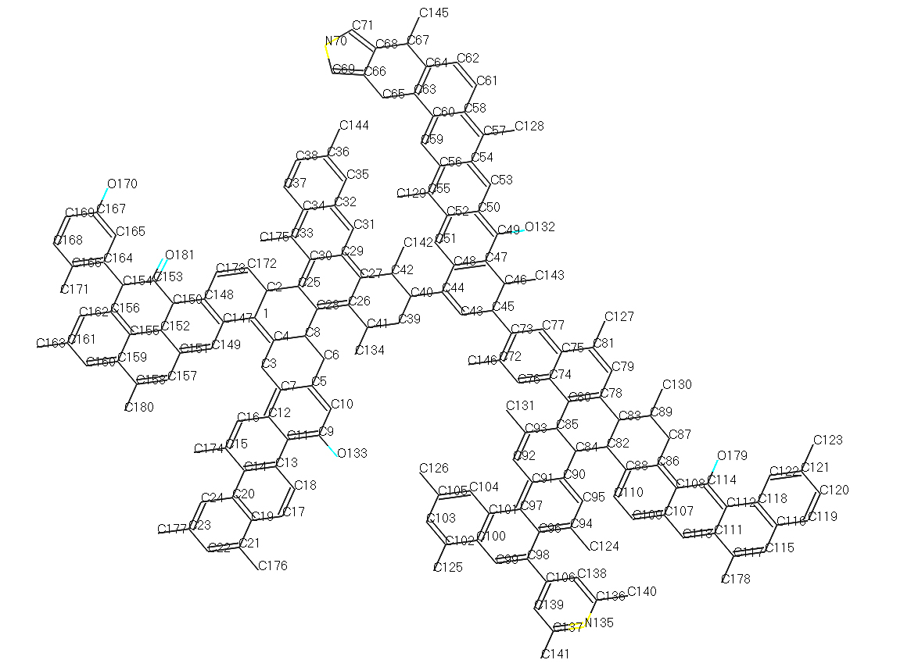

Fig.3 Macromolecular Model of No.2 Dongqu Coal

***2.2. The Pyrolysis Simulation of No. 2 Dongqu Coal Structure Model***

***2.2.1. The Pyrolysis Simulation Analysis of Single Coal Macromolecular***

During the pyrolysis simulation of single coal macromolecule, the lowest energy configuration was calculated(Fig. 4). After the simulation, the energy at the start point and the energy at the end point (Table 4) were selected for comparison.

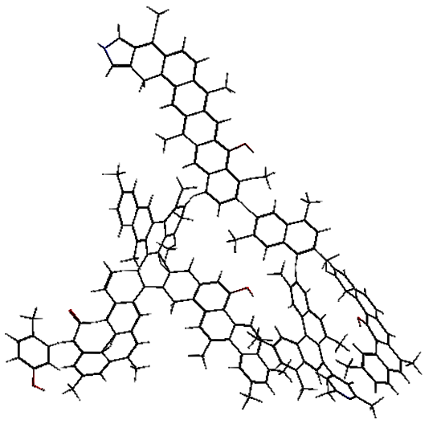

Fig.4 Energy- minimum Configuration of No.2 Dongqu Coal

Table4 Energy (kcal /mol) Comparison before and after Single Molecular Dynamics

|  |  |  |  |  |  |  |  |
| --- | --- | --- | --- | --- | --- | --- | --- |
| Simulated Condition | Ebond | Eatom | Etors | Evdw | Echarge | Etotal | |
| Start | -62408.01 | 782.27 | 223.29 | 20311.21 | 806.09 | | -36384.39 |
| End | -69678.87 | 960.86 | 191.72 | 16381.67 | 901.39 | | -43087.92 |

From Table 4, it is can be seen that the total energy is reduced from -36384.39 kcal/mol to -43087.92 kcal/mol, and that the bond energy is reduced from -62408.01 kcal/mol to -69678.87 kcal/mol after the single molecular dynamics simulation, causing the torsional energy and the energy of van der Waals force were reduced accordingly. The reason for the phenomenon is that various functional group fragments were generated inside the system during the pyrolysis process, resulting in the reduction in total energy, bond energy, torsional energy, and energy of van der Waals force in the system. However, the atomic energy in the system increased from 782.27 kcal/mol to 960.86kcal/mol, and the charge energy increased from 806.09 kcal/mol to 901.39kcal/mol, indicating that the system’s stability got enhanced after macromolecule was splited into fragments in the simulated condition where temperature rose in this system.

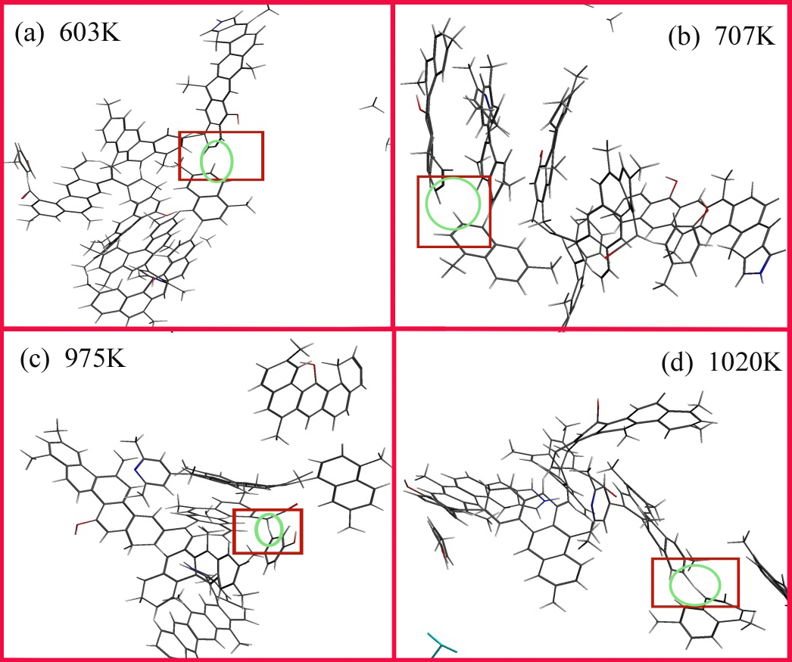

Fig.5 Pyrolysis Process of Single Macromolecule

The macromolecule was hydrotreated in the lattice so as to obtain the lowest energy configuration, and pyrolysis reaction simulation of the single macromolecule was conducted. The reaction process was as follows: At around 603K, the first macromolecular fragment was cleaved off from the main structure (Fig. 5_a), and at the same time, the total energy of the macromolecule in this chemical environment increased due to the increase of the temperature inside the system,, so the relatively active C73-C45 bond on the main chain of the macromolecular structure model ruptured, causing molecular fragments containing the two branched chain N135,O179 detached from the main chain, resulting in two macromolecular fragments.

The second fragment was detached from the first macromolecular fragment (Fig. 5_b) when the temperature was at about 707K. At 603K, there were two branched chains in the macromolecular fragment detached from the main chain, and the fatty carbon bond C84-C82 connecting the two branched chains ruptured, causing the decrease of cross-linking property. In such chemical environment, the relatively active C83-C78 ruptured, causing the falling of the branched chain containing O179 from the fragment just detached from the main chain.

The third fragment fell off from the structure (Fig. 5_c) when the temperature was around 975K. In the chemical environment, the surrounding C got relatively active due to O170 and O181, causing the rupture of C164-C154 (Fig. 6) and thus the generation of a p-methylphenol.

The fourth fragment fell off from the main structure (Fig. 5_d) when the temperature was around 1020K. After the second fragment fell off, C85-C80 ruptured, producing a molecular fragment and dimethylnaphthalene. It showed that the rupture of the main bond during coal pyrolysis occurs in a relatively low temperature environment (<1100K) mostly.

***2.2.2 The Pyrolysis Simulation Analysis of Coal Molecular Group***

The lowest energy configuration(Fig. 7) was worked out during the pyrolysis simulation process of molecular group consisted of the five coal structure model molecules. After the simulation, the process of methane formation was clear and methane precipitation rate curve were obtained (Fig. 8), and the energy at the start point and that at the end point(Table 4) were selected for comparison.

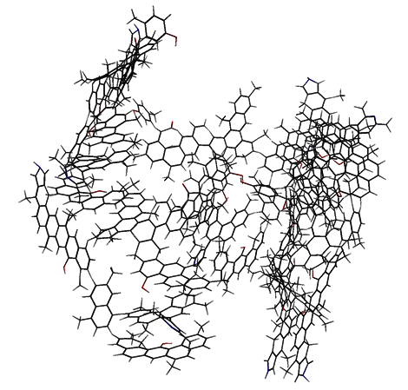

Fig.7 Energy- minimum Configuration of Molecular Group

Table5 Comparison of Energy (kcal /mol) before and after Molecular Dynamics Simulation

|  |  |  |  |  |  |  |
| --- | --- | --- | --- | --- | --- | --- |
| 模拟状态 | Ebond | Eatom | Etors | Evdw | Echarge | Etotal |
| Start | -298394.73 | 4804.16 | 958.85 | 81883.61 | 4017.62 | -215469.43 |
| End | -298501.77 | 4844.86 | 952.87 | 81839.13 | 4068.73 | -215606.38 |

According to Table 5, it can be seen that the total energy was reduced from -215469.43 kcal/mol to -215606.38kcal/mol, and that bond energy was reduced from -298394.73kcal/mol to -298501.77kcal/mol through molecular group dynamics simulation, causing both torsional energy and the energy of van der Waals force were correspondingly reduced. The reason for the phenomenon is that the molecular group generated various functional group fragments in the pyrolysis process under the corresponding chemical environment, resulting in the reduction of of total energy, bond energy, torsion energy and the energy of Van der Waals' force inside the system. However, atomic energy and charge energy inside the system increased. The result corresponded to the energy changes before and after the single molecular dynamics simulation, and it conformed to the basic principle of system energy conservation.



Fig.8 Methane Precipitation Rate Curve during the Process of Molecular Group Pyrolysis Simulation



Fig.9 The Potential Energy Changing Curve during the Process of Molecular Group Pyrolysis Simulation

From the methane generation rate curve (Fig. 8) in the pyrolysis simulation process, it can be seen that methane starts to precipitate when the temperature is about 2200K, and that the precipitation rate reaches the maximum when it is at 2580K and the rate is close to zero when the final temperature for pyrolysis is 3000K. During the pyrolysis process, the potential energy of the system (Fig. 9) is rapidly increased due to the action of the force field and the rapid temperature change at the beginning of the simulation. The system energy in the NVT ensemble increases rapidly, which is manifested by the rapid increase of the potential energy of the system. After a short period of time, the system pyrolysis reaction is stable, the potential energy of the system decreases rapidly, and the subsequent overall trend tends to increase with time.

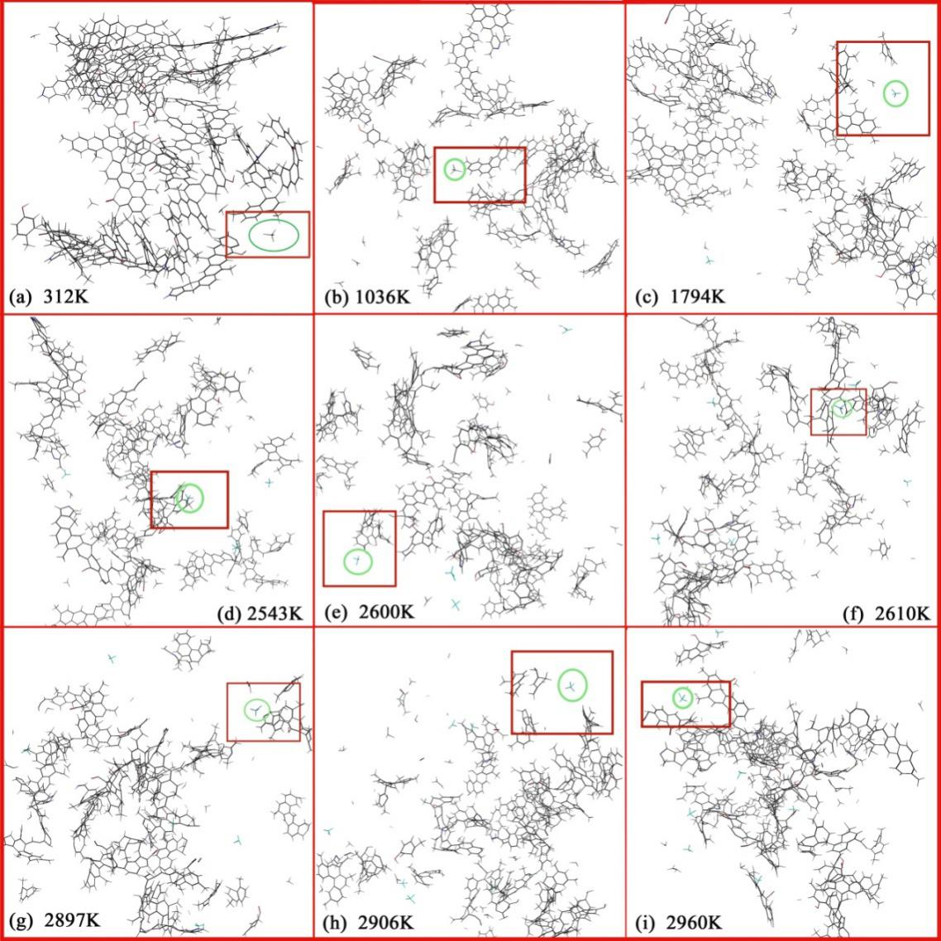

Fig.10 Description of the Pyrolysis Process of Molecular Group

In the pyrolysis simulation process of Dongqu No.2 Coal macromolecular structure model, the formation of methane (Fig. 10) is mainly from the primary or secondary detachment of methyl groups on several major side chain functional groups of the coal structure in the force field system, ReaxFF.

In SCM MOVIE, the method of methane formation was tracked. When it was around 312K, the methyl group C130 was detached due to the breaking of the bond, C130-C89 and combined with hydrogen ions, thus the first methane molecule was formed (Fig. 10_a). At the beginning of the simulation process, the rapid increase of the system's potential energy led to the drastic change of the molecular group composed of the five macromolecular models in the system, so relatively unstable C130 at the edge of the molecular group detached and formed a benzyl group to form a methane.

The second methane molecule formed (Fig. 10_b) when it was around 1036K, for the side branch chain broke from the molecular group, and the breaking of bond C163-C161 on this branch facilitate the methyl group C176 to detach from the quaternary benzene ring to form a benzyl group to form methane.

The third methane molecule is produced (Fig. 10_c) when it was at around 1794K, for cyclohexane C28-C8, C8-C6 in the molecular ruptured, sothe bond between C8-C4 connected, and then the force field under the temperature rendered C8 to detach from the side chain fragment to form methane.

The fourth methane molecule formed (Fig. 10_d) when it was around 2543K, for C180 detached fromC180-C158 on the side chain fragment in the molecular group，forming benzyl and forming methane.

**Acknowledgements**

This work was financially supported by NSFC-Shanxi Coal-based Low Carbon Joint Fund (Project is Experiments and Molecular Modeling of Multi-scale Structural Characteristics of Coking Coal and Its Relationship with Pyrolysis Reactivity, No.U1510102).

**References**

1. Fuchs W, Sandhoff A G. Theory of Coal Pyrolysis[J]. Ind.eng.chem, 2002, 34:567-571.

2. Hatcher P G, Faulon J L, Wenzel K A, et al. A structural model for lignin-derived vitrinite from high-volatile bituminous coal (coalified wood)[J]. Energy & Fuels, 1992, 6(6):813-820.

3. JIA Jian-bo, ZENG Fan-gui, SUN Bei-lei. Construction and modification of macromolecular structure model for vitrinite from Shendong 2-2 coal[J]. [Journal of Fuel Chemistry and Technology](javascript:void(0)) , 2011, 39(9):652-657.

4. XIANG Jian-hua, ZENG Fan-gui, LIANG Hu-zhen, et al.Model construction of the macromolecular structure of Yanzhou coal and its molecular simulation[J]. [Journal of Fuel Chemistry and Technology](javascript:void(0)) , 2011, 39(7):481-488.

5. XIANG Jian-hua, ZENG Fan-gui, LI Bin, et al, Construction of macromolecular structural model of anthracite from Chengzhuang coal mine and its molecular simulation[J]. [Journal of Fuel Chemistry and Technology](javascript:void(0)), 2013, 41(4):391-399.

6. Wu L, Zhu Y. Structural Characteristics of Coal Vitrinite during Pyrolysis[J]. Energy & Fuels, 2014, 28(6):3645-3654.

7. Li Z K, Wei X Y, Yan H L, et al. Insight into the structural features of Zhaotong lignite using multiple techniques[J]. Fuel, 2015, 153:176-182.

8. MA Yan-ping, Xiang Jian-hua, LI Mei-fen,et al. Macromolecular structural model of the pyridine extracted residue of vitrain from No.3 coalbed, Liu lin and molecular simulation[J]. . [Journal of Fuel Chemistry and Technology](javascript:void(0)), 2012, 40(11):1300-1309.

9. ZENG Fan-gui, JIA Jian-bo, Reaction Types and Kinetics of Methane Generation from Huolinhe Lignite Pyrolysis by TG/MS Experimen and Quantum Chemical Calculations[J]. Acta Physico-Chimica Sinica, 2009, 25(6):1117-1124.

10. LI Mei-fen, ZENG Fan-gui, SUN Bei-lei, et al. Evolution Kinetics of Hydrogen Generation from Low Rank Coal Pyrolysis and Its Relation to the First Coalification Jump. [J]. Acta Physico-Chimica Sinica, 2009, 25(12):2597-2603.

11. Han F, Meng A, Li Q, et al. Thermal decomposition and evolved gas analysis (TG-MS) of lignite coals from Southwest China[J]. Journal of the Energy Institute, 2016, 89(1):94-100.

12. Arenillas A, Rubiera F, Pis J J. Simultaneous thermogravimetric–mass spectrometric study on the pyrolysis behaviour of different rank coals[J]. Journal of Analytical & Applied Pyrolysis, 1999, 50(1):31-46.

13. Mingjie Gao, Xiaoxia Li, Li Guo. Pyrolysis simulations of Fugu coal by large-scale ReaxFF molecular dynamics [J]. Fuel Processing Technology, 2018, 178:197-205.

14. Dikun Hong, Xin Guo. Molecular dynamics simulations of Zhundong coal pyrolysis using reactive force field, 2017, 210:58-66

15. Shui H, Koyo Norinaga A, Iino M. Characterizations of Aggregation States of Coal Soluble Constituents at Solid State[J]. Energy & Fuels, 2002, 16(1):69-73.

16. Liu S, Zou C, Zhao J, et al. Speciation of Sulfur and Regularity of Pyrolysis Gas Evolution in Different Coking Coals[J]. Coal Conversion, 2018.

17. Zheng M, Wang Z, Li X, et al. Initial reaction mechanisms of cellulose pyrolysis revealed by ReaxFF molecular dynamics[J]. Fuel, 2016, 177(AUG):130-141.

18. Li G Y, Wang F, Wang J P, et al. ReaxFF and DFT study on the sulfur transformation mechanism during the oxidation process of lignite[J]. Fuel, 2016, 181:238-247.

19. Castro-Marcano F, Kamat A M, Jr M F R, et al. Combustion of an Illinois No. 6 coal char simulated using an atomistic char representation and the ReaxFF reactive force field[J]. Combustion & Flame, 2012, 159(3):1272-1285.

20. Bhoi S, Banerjee T, Mohanty K. Molecular dynamic simulation of spontaneous combustion and pyrolysis of brown coal using ReaxFF[J]. Fuel, 2014, 136(6):326-333.

21. Castro-Marcano F, Jr M F R, Duin A C T V, et al. Pyrolysis of a large-scale molecular model for Illinois no. 6 coal using the ReaxFF reactive force field[J]. Journal of Analytical & Applied Pyrolysis, 2014, 109:79-89.

22. Mathews J P, Chaffee A L. The molecular representations of coal – A review[J]. Fuel, 2012, 96(7):1-14.

23. Castro-Marcano F, Lobodin V V, Rodgers R P, et al. A molecular model for Illinois No. 6 Argonne Premium coal: Moving toward capturing the continuum structure[J]. Fuel, 2012, 95(1):35-49.

24. ZHU Yin-hui, WANG Zhong-hui, coal hemistry[M]. Chemical Industry press, 2013